Data Storage in WP10 – User Guide

Objective
The goal of WP10 is not only to deliver pipelines and code, but also to provide datasets to ensure that the code is runnable and reproducible. Where possible, trained model objects can also be shared. In most cases, input datasets cannot be shared openly; in those cases, WP10 will aim to provide small, representative samples to illustrate the structure and content of the actual data.
To support this, we will use the data storage system provided by Onyxia. Each WP10 member will have access to the WP10 dedicated bucket and will be able to upload datasets and manage access permissions.
Note: Onyxia uses buckets for data storage—containers that hold files and objects using a flat structure with unique identifiers, instead of a traditional folder hierarchy.

Prerequisites
Before uploading or accessing data, each WP10 member must:
- Create an account on Onyxia by following this link:
Onyxia Registration
- Share their Onyxia and GitHub usernames with the WP10 lead by filling out the file:
GitHub & Onyxia accounts.xlsx
This information will be forwarded to WP3, who will grant you access to the shared WP10 bucket.

How to Upload Data and Manage Access in the WP10 Bucket
Once access is granted:
- Log in to Onyxia.
- Switch from your private space to the WP10 project space using the project selector in the top navigation bar.
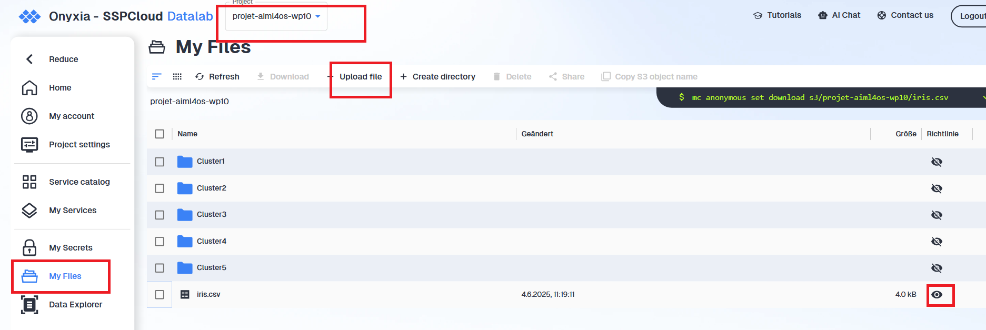
- Go to the “My Files” section and navigate to the folder corresponding to your cluster.
- Click the “Upload File” button to add your data files.
- After uploading, click on the eye icon next to your file to manage visibility:
  - Private (default): represented by a crossed-out eye.
  - Public: click the eye icon to remove the cross and make it visible to others.
- Click on the “Share” button:
  - This allows you to check the visibility status of your file.
  - You can also copy the download link, which can be shared with others — even people who are not Onyxia users.
